St. Francis Institute of Technology, Mumbai-400 103

**Department Of Information Technology**

A.Y. 2023-2024

Class: TE-ITA/B, Semester: V

Subject: **DevOps Lab**

**Experiment– 9: To understand Docker Architecture and Container Life Cycle, install Docker and execute docker commands to manage images and interact with containers.**

**7b**. **Execute following (Refer the shared material) and attach screenshots:**

* + - Create Docker Hub account – screenshot of steps related to account creation

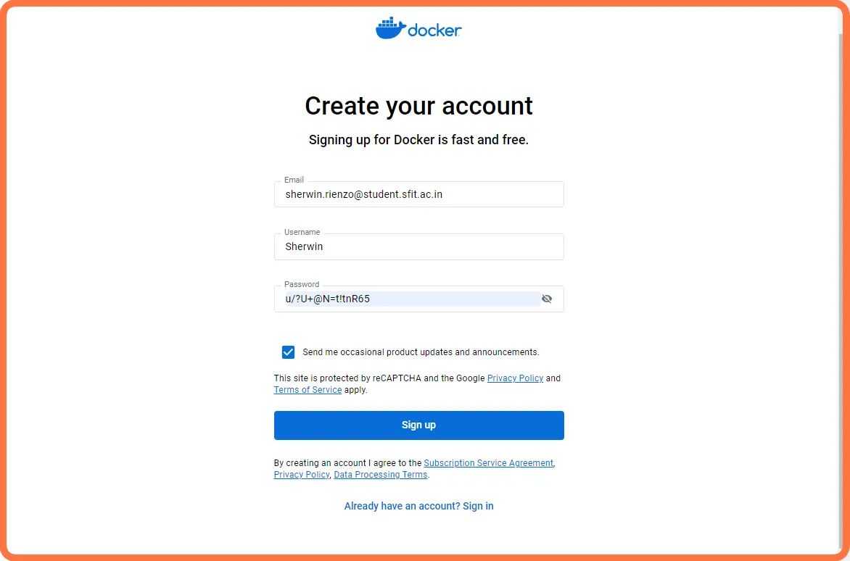

* Download and install Docker Desktop – screenshots of installation steps

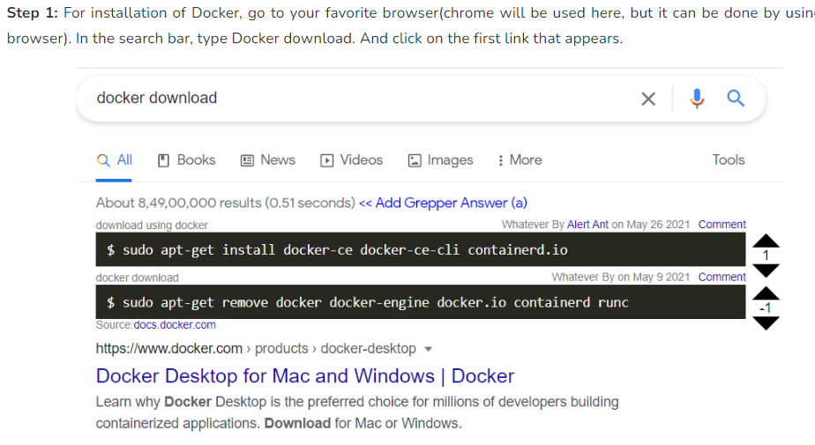

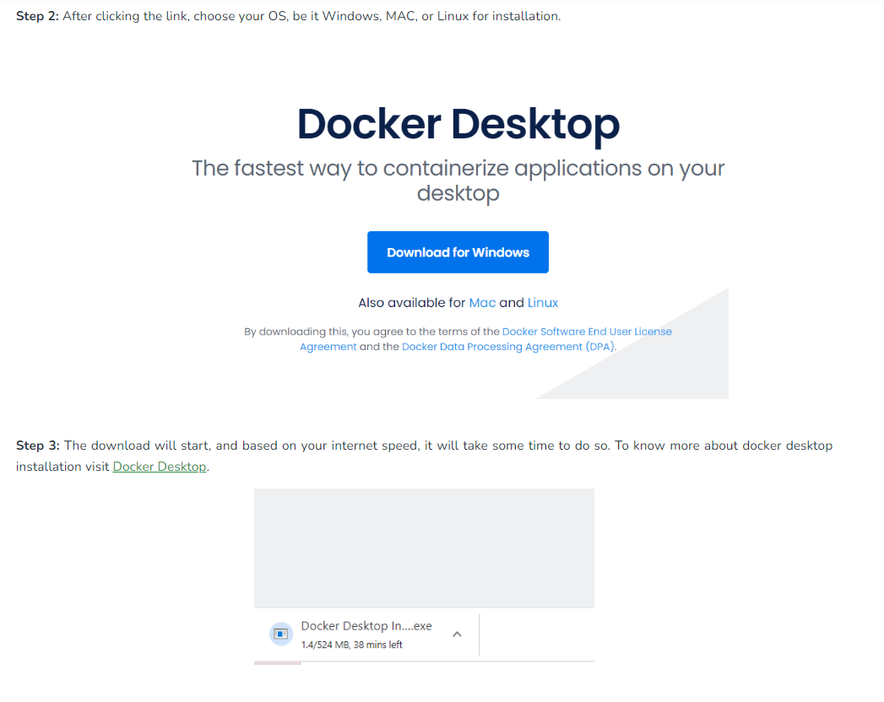

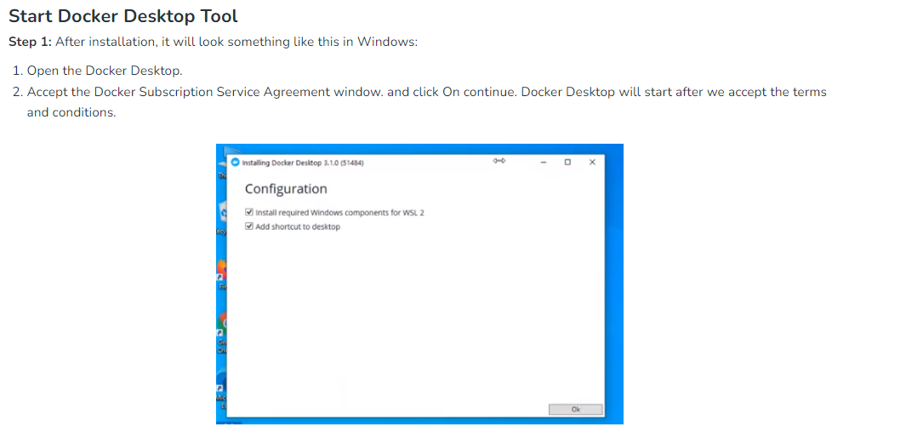

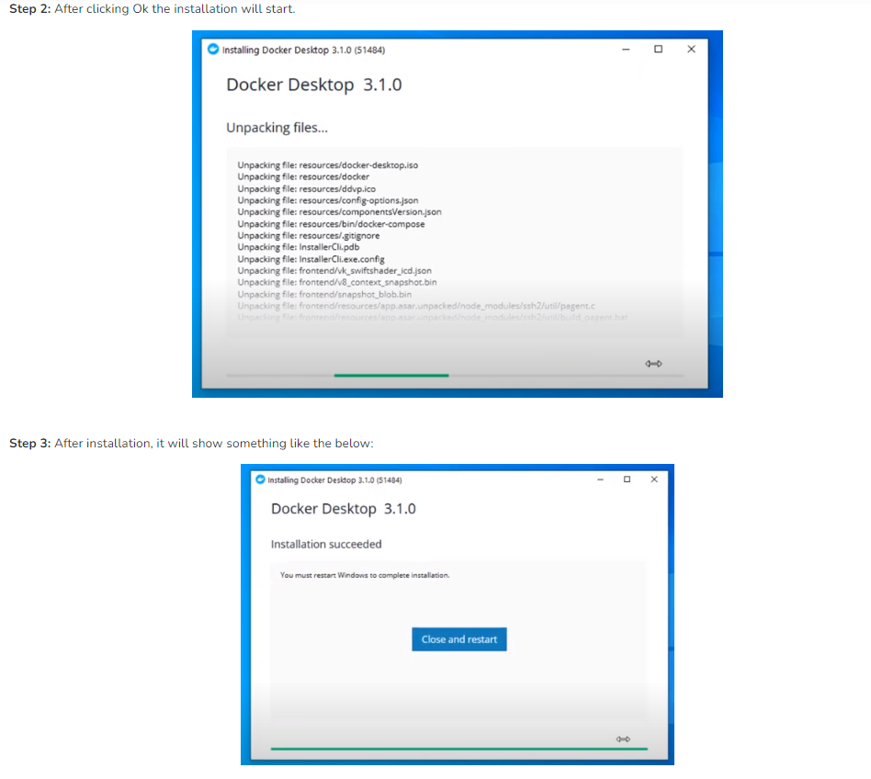

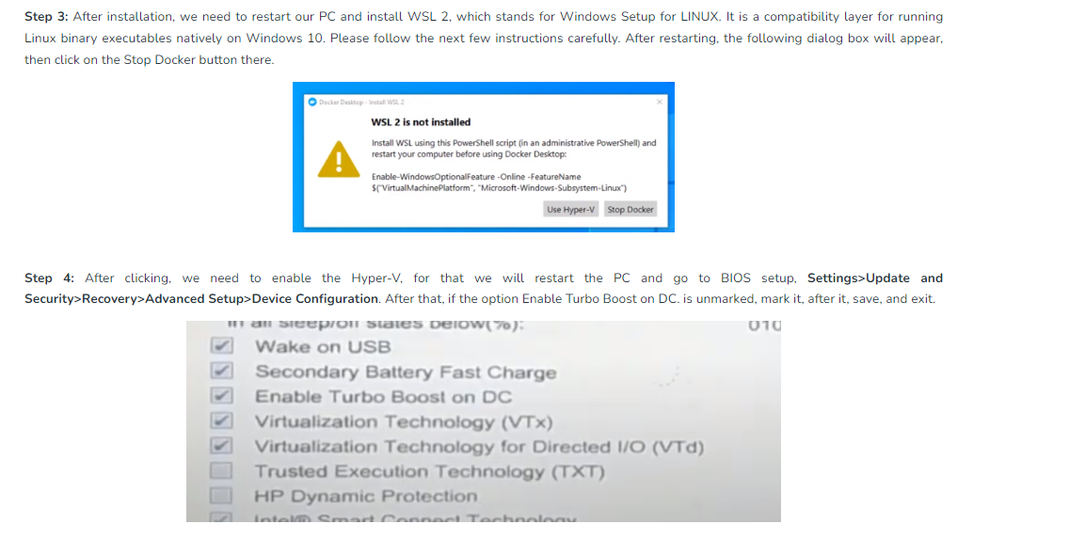

* Execute following docker commands and take screenshots

1. Docker version

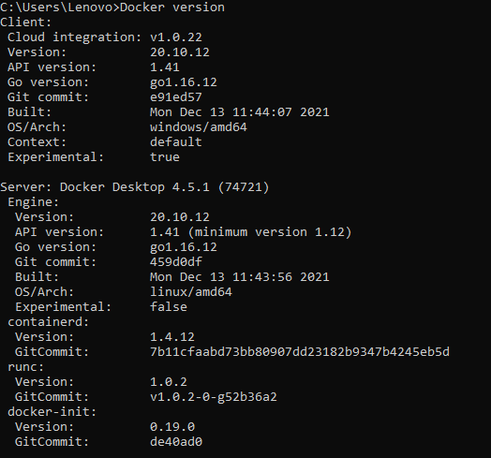

1. Docker login

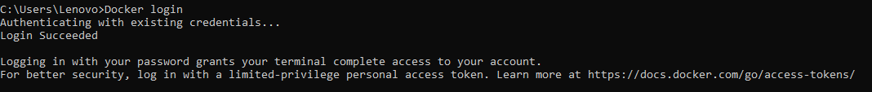

1. Docker images

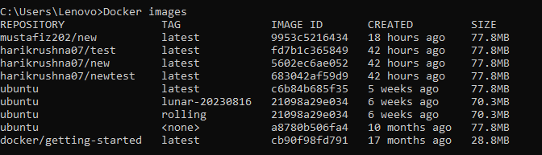

1. Docker pull image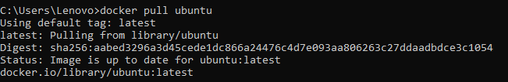
2. Docker pull image-tag

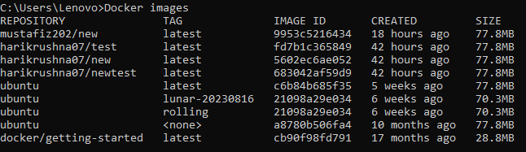

1. Docker images help

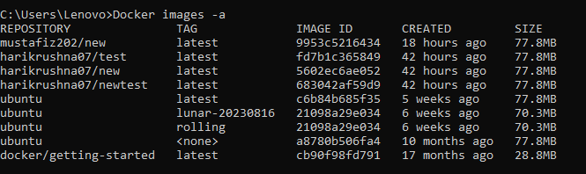

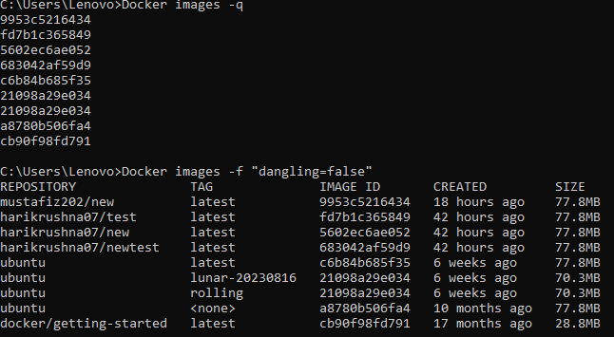

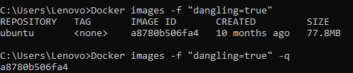

1. Docker run commands



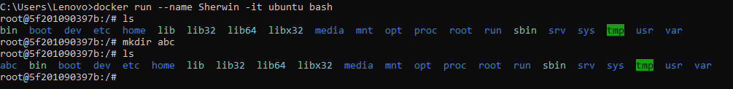

1. Docker ps

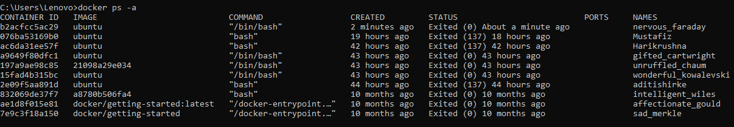



1. Docker start container

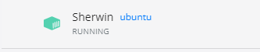

1. Docker pause container









1. Docker stop container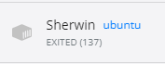
2. Docker top container
3. Docker stats container

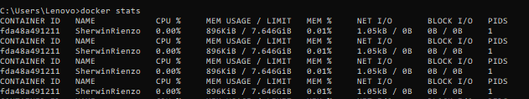

1. Docker rm container



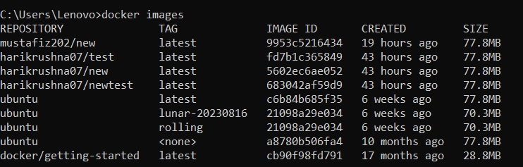

1. 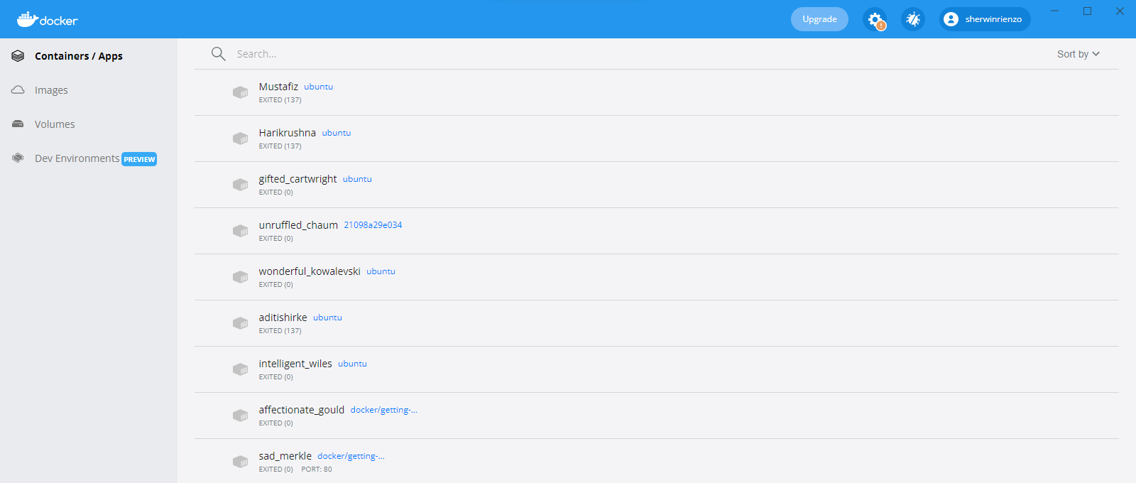Docker inspect

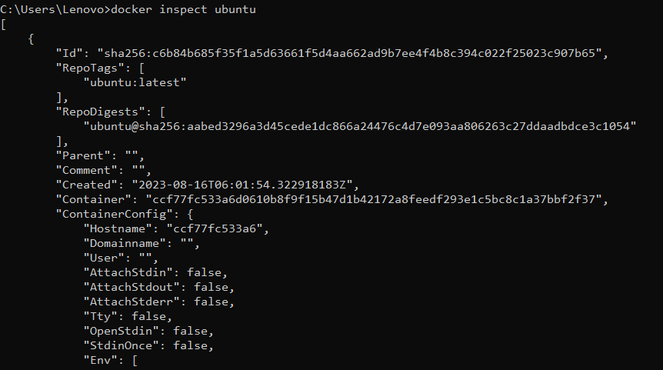

1. Docker rmi

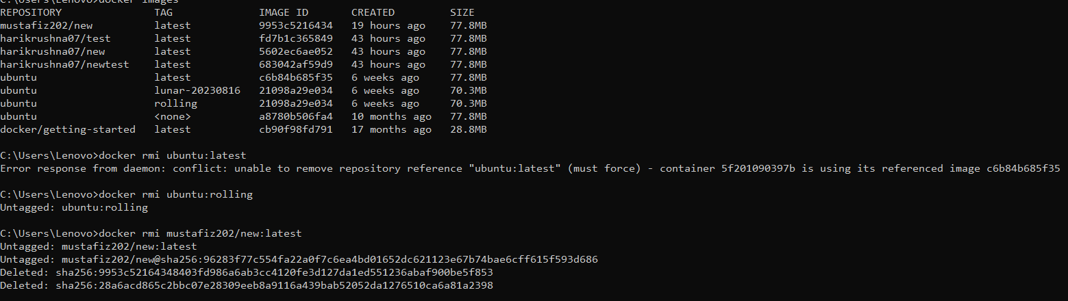

1. Docker commit

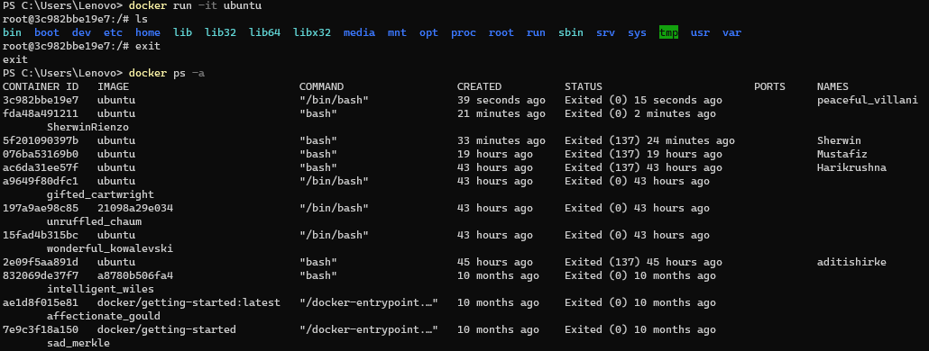





1. **Docker push**

**THIS COMMAND DIDN’T WORK DUE TO SOME TECHNICAL FAILURE MA’AM YOU SAID NO NEED TO PUT THE SCREENSHOT FOR THIS**

1. Docker history image

